**Practical :7**

**Aim: Sharding using Mangodb**

Step 1: Create 6 folders in drive.

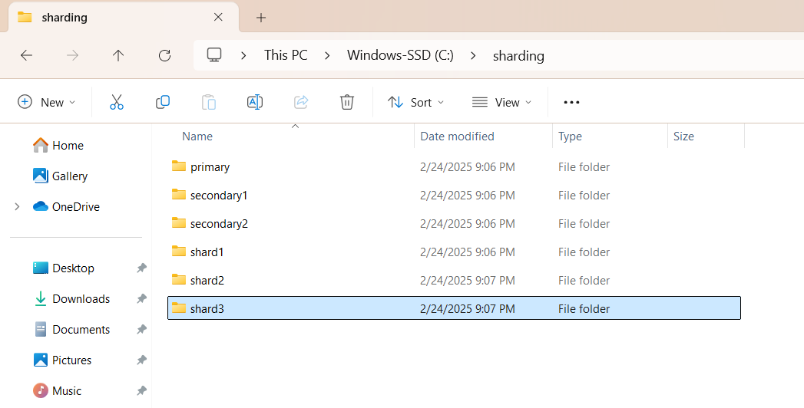

**Step 2: Initialize MongoDB Config Servers (on different CMD)**

mongod --configsvr --port=1230 --replSet="replica-set1" --dbpath="C:\sharding\primary"

mongod --configsvr --port=1240 --replSet="replica-set1" --dbpath="C:\sharding\secondary1"

mongod --configsvr --port=1250 --replSet="replica-set1" --dbpath="C:\sharding\secondary2"

**Step 3**: **Connect using mongosh**

mongosh --host="localhost:1230"

rs.initiate({

... _id:"replica-set1",

... configservr:true,

... members:[

... { _id:0,host:"localhost:1230"},

... { _id:1,host:"localhost:1240"},

... { _id:2,host:"localhost:1250"}

... ]

... })

**Step 4: Configure Shards**

mongod --shardsvr --port=1330 --dbpath="C:\sharding\shard1" --replSet="replica-set2"

mongod --shardsvr --port=1340 --dbpath="C:\sharding\shard2" --replSet="replica-set2"

mongod --shardsvr --port=1350 --dbpath="C:\sharding\shard3" --replSet="replica-set2"

**Step 5: Connect using mongosh**

**mongosh --host="localhost:1330"**

**rs.initiate({**

**... _id:"replica-set1",**

**... configsvr:true,**

**... members:[**

**... { _id:0,host:"localhost:1230"},**

**... { _id:1,host:"localhost:1240"},**

**... { _id:2,host:"localhost:1250"}**

**... ]**

**... })**

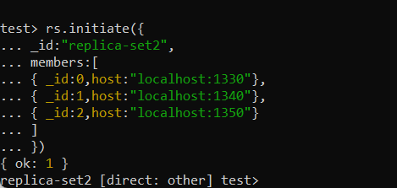

**Step 5: Initialize a Query Router which is a mongos process.**

mongos --port=1210 --configdb="replica-set1/localhost:1230,localhost:1240,localhost:1250"

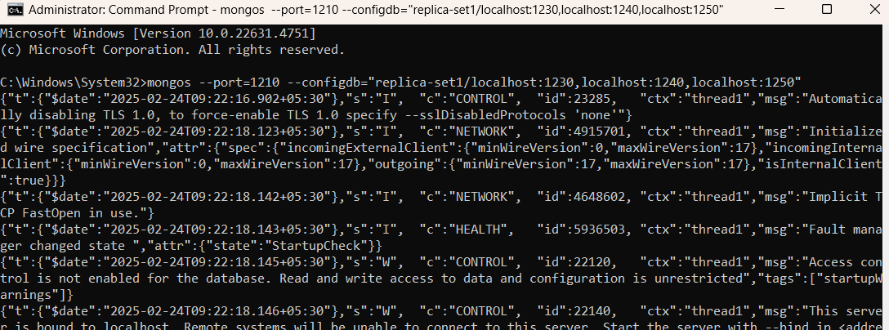

**Step6: Now, Connect Shards and Query Router**

mongosh --host="localhost:1210"

**Step 7: Adding Shard Replica Set to Sharded Cluster**

sh.addShard("replica-set2/localhost:1330,localhost:1340,localhost:1350")

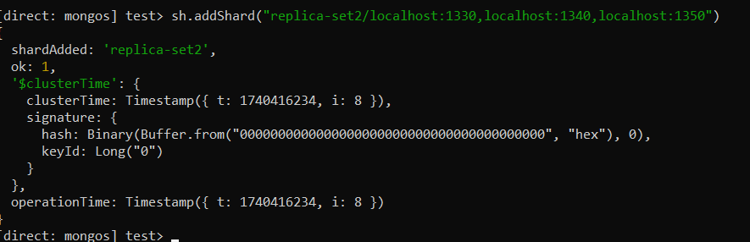

**Step8: Enable Sharding on a Specific Database of Shards Replica Set**

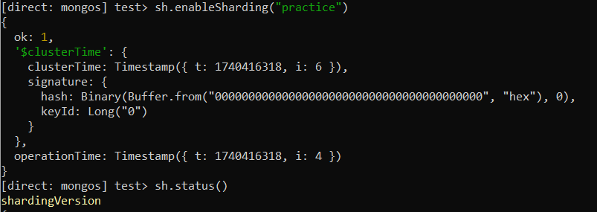

**Step 9: Shard a Collection on the Sharding Enabled Database**

sh.shardCollection("practice.students", { "enroll": "hashed" })

use practice

db.students.insertMany([

{ _id: 1, name: "Virat", enroll: 1001 },

{ _id: 2, name: "Rohit", enroll: 2005 },

{ _id: 3, name: "Akaxar", enroll: 1503 },

{ _id: 4, name: "Jadeja", enroll: 2507 },

{ _id: 5, name: "Hardik", enroll: 3002 },

{ _id: 6, name: "Bumrah", enroll: 3501 }

])

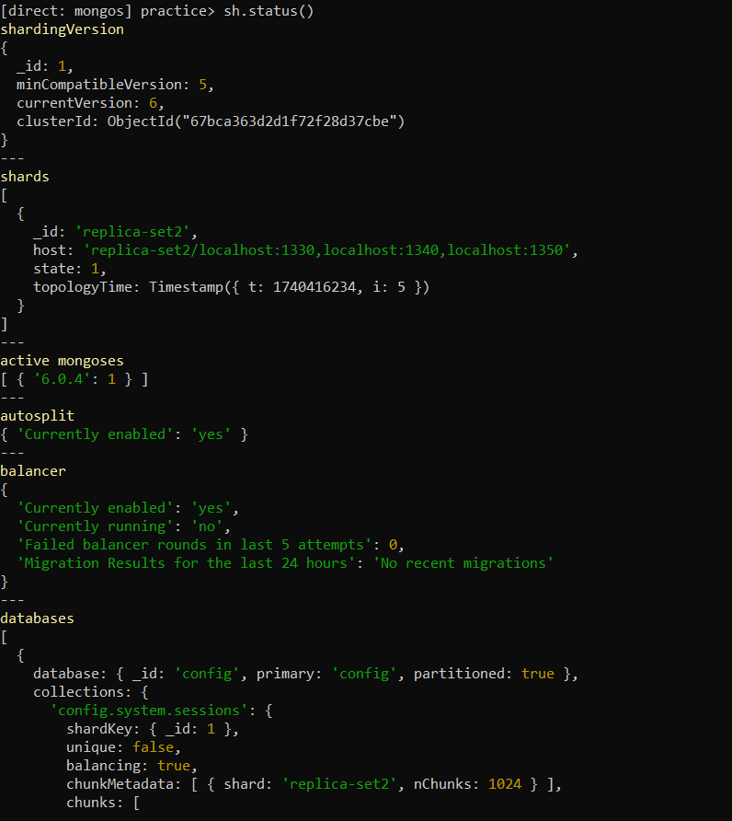

**db.students.find({ enroll: 2005 })**

